Patrick Griffin

3/4/17

Class Participation #3

***Counter.cpp***

Output for Counter.cpp

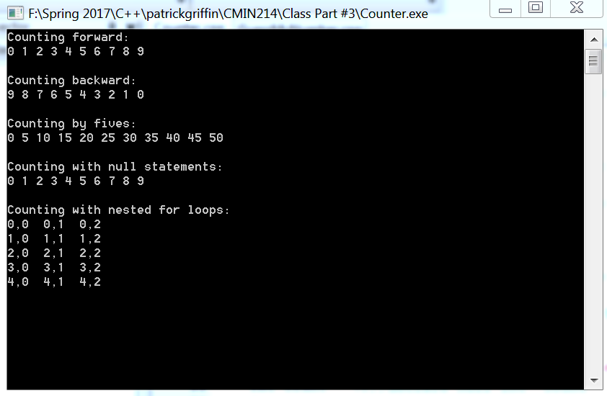

***StringTester.cpp***

Output for StringTester.cpp

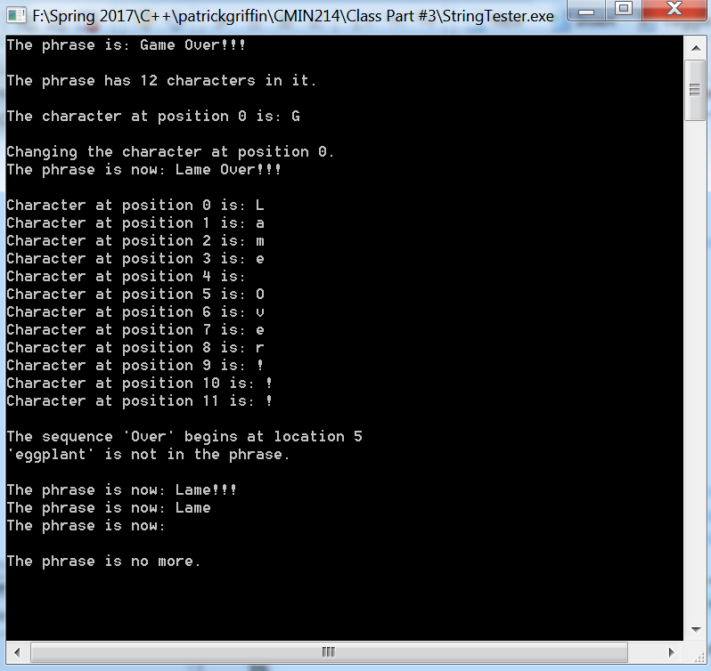

***HerosInventory.cpp***

Output for HerosInventory.cpp

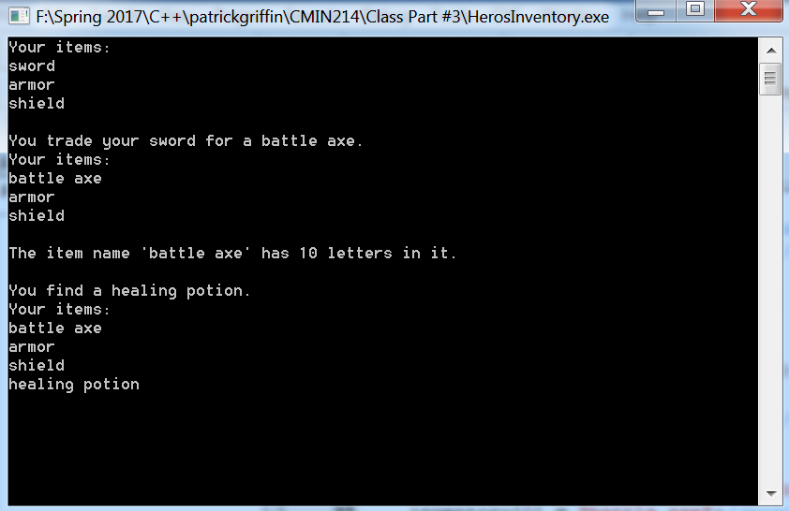

***Tic-Tac-ToeBoard.cpp***

Output for Tic-Tac-ToeBoard.cpp

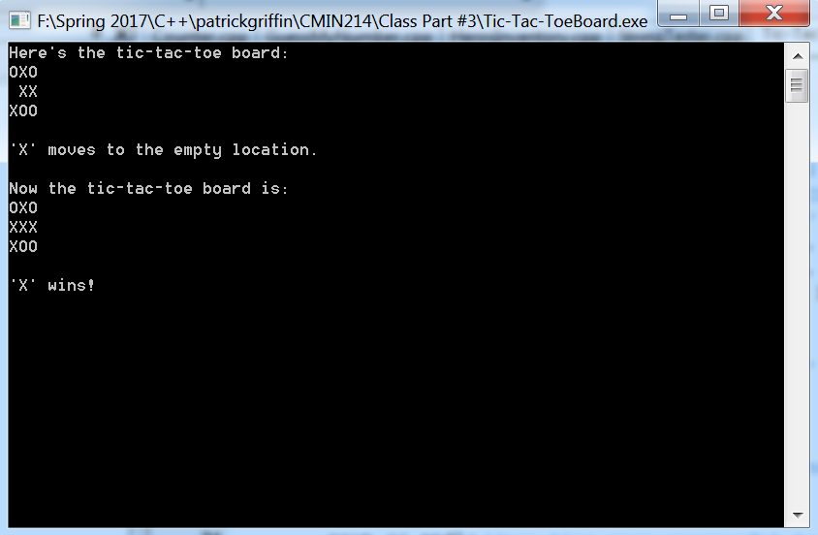

***WordJumble.cpp***

Output for WordJumble.cpp

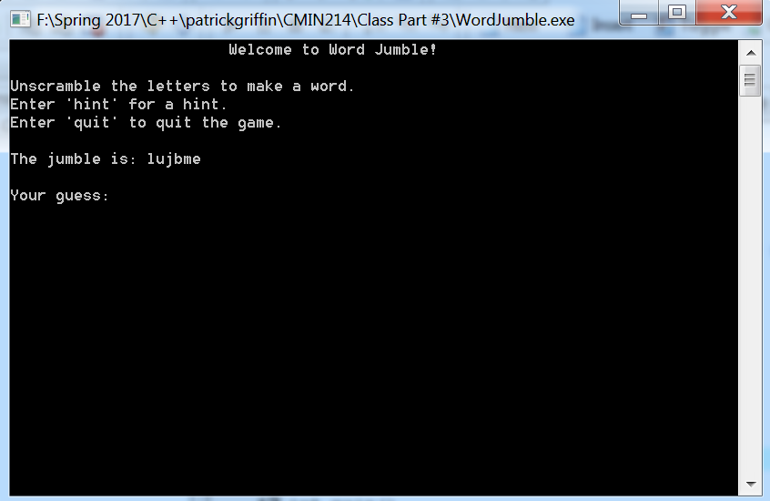

input:

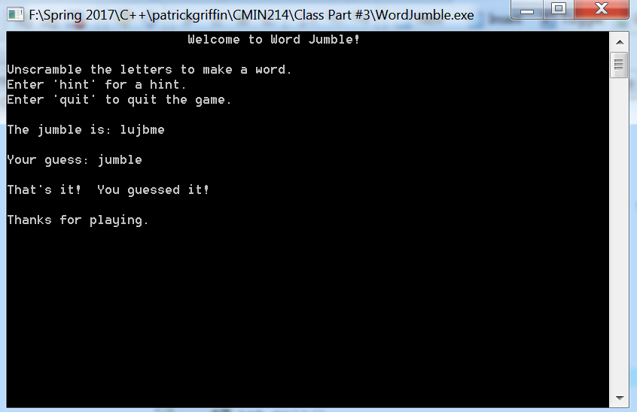

output:

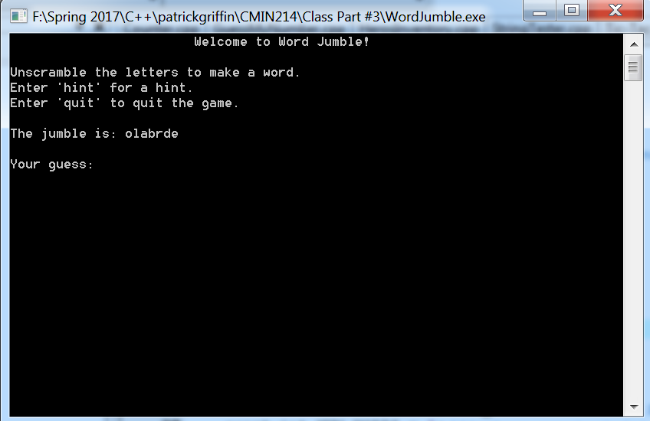

input:

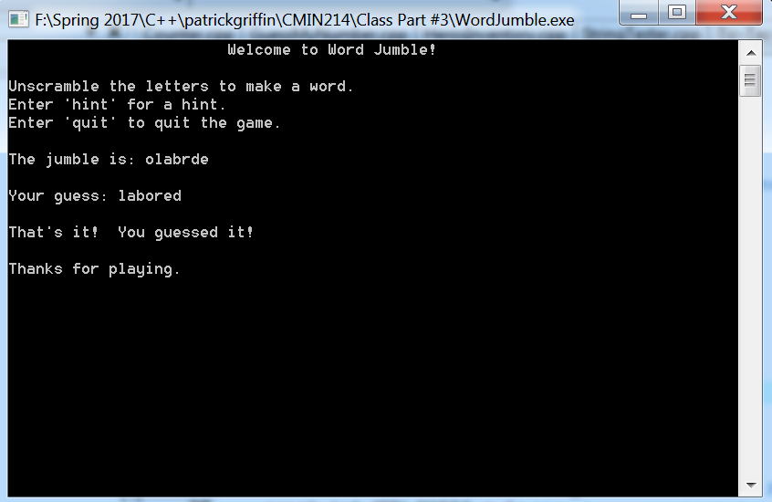

output:

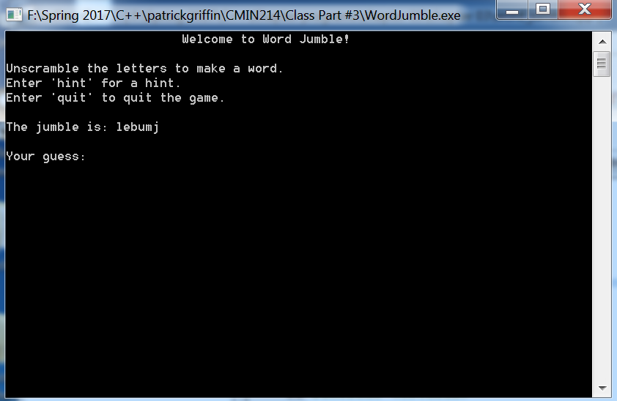

input:

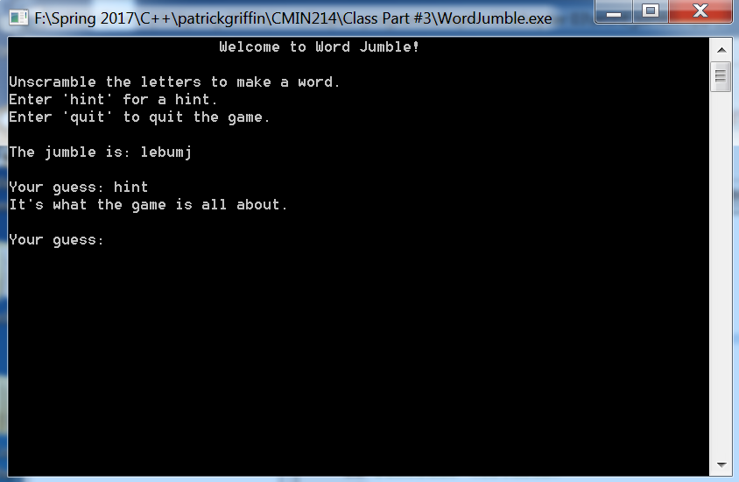

input:

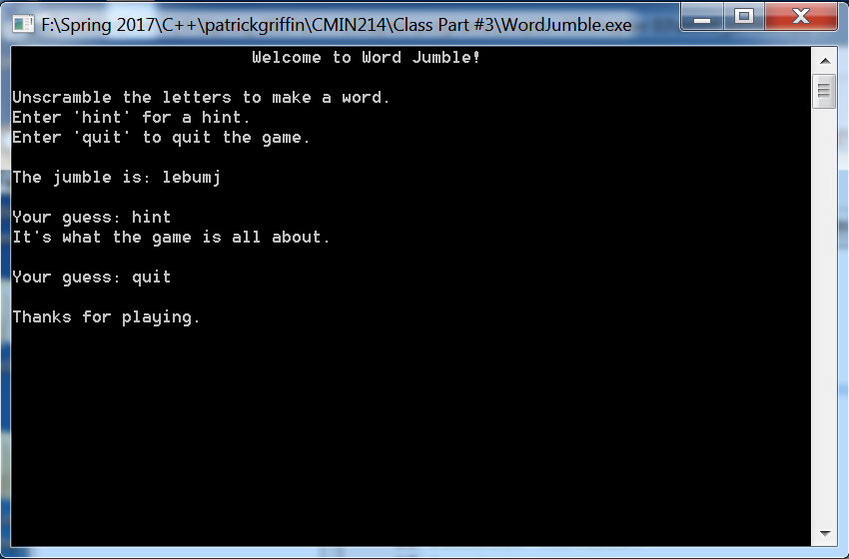

***RewriteHeroInventory.cpp***

Output for RewriteHeroInventory.cpp

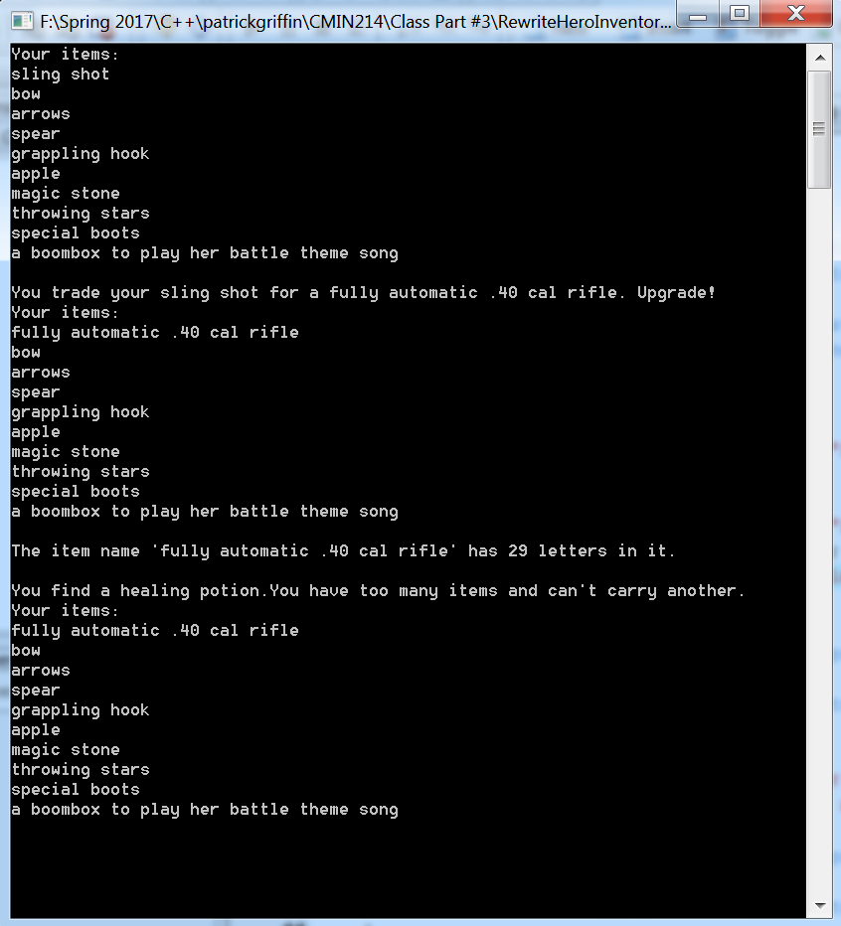

***WordJumble2.0.cpp***

Output for WordJumble2.0.cpp

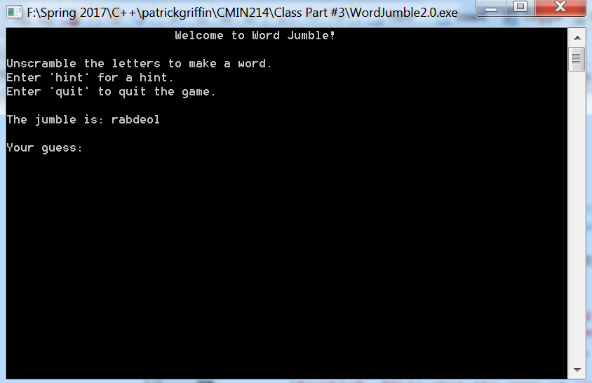

input

